MINI PROJECT - AIRLINE RESERVATION

AIM :

Airline reservation system main aim is to provide the online ticket & seat reservation of National Flights and also give us the information about flight availability. In this java major project mainly we are going to concentrate on ticket booking function, this function will take the user inputs like their requirements (flight name, flight source & destination, Number of seats, Seat numbers), after entering all of his/her requirements in this application, it can check at backend & provide us the total information about flights. When we open the first page of this project we can find the basic information of the booked ticket and cancel tickets if necessary.

ALGORITHM :

❖ Create a Project in Eclipse. Then Install MySQL from the Internet and Configure it.

* Download the Connector JAR File from the Internet and put it inside the ext repository. Then add the JAR file inside the project by Libraries repository.

* Now the MySQL has been Connected Successfully. Then add the schema, Tables inside the MySQL workbench and insert all the values inside the Table using the query Statements.

* Then in the Java file You need to load the Driver Class and connect the schema.

* Load the Driver Class com.mysql.jdbc.Driver. Then connect the schema using

Connectioncon=DriverManager.getConnection(jdbc:mysql://localhost/airtickconnection","root","SwathiShri@123");

❖

Then create a ResultSet in which the Query can be executed.

❖

Now the JDBC Work has been completed and now the Front End Part.

FRAME 1 :

* The frame 1 page is the login ans sign up page if it is new user ,click the sign up button to move to the sign up frame (frame 2) else if it is a alredy registerd user click the login button(frame3)

FRAME 2:

* Enter the customer id and password and register the user and display a dialouge box message that the details are saved in the database.

FRAME 3:

* Enter your customer id and password if you are already registered user display a dialouge box message the entered details is correct else print incorrect id and password .
* Then click on the book button to go to the booking page

(frame 4)

FRAME 4:

* It is the booking page fill in the details like the user name ,destination,flight no,passort number ..and also view the fights which are available
* After entering the details click on the book button and a dialogue box is displayed and the datas are stored in the database

FRAME 5:

* To view the booked ticket click on the already registered button in the login page to view your booked ticket by entering your customer id

FRAME 6 :

* If the user want to cancel a ticket ,it can be canceled by entering the customer id and can view the details before cancelling .

PROGRAM :

Main page

package airtick;

import java.awt.EventQueue;

import java.awt.event.*;

import javax.swing.JFrame;

import java.awt.GridLayout;

import javax.swing.JPanel;

import javax.swing.JLabel;

import javax.swing.JOptionPane;

import javax.swing.SwingConstants;

import java.awt.FlowLayout;

import java.awt.BorderLayout;

import java.awt.CardLayout;

import java.awt.Color;

import java.awt.Component;

import javax.swing.BoxLayout;

import javax.swing.GroupLayout;

import javax.swing.GroupLayout.Alignment;

import javax.swing.ImageIcon;

import javax.swing.LayoutStyle.ComponentPlacement;

import airtick.mysqlonnection;

import javax.swing.JTextField;

import javax.swing.JButton;

import java.awt.event.ActionListener;

import java.io.IOException;

import java.sql.Connection;

import java.sql.PreparedStatement;

import java.sql.ResultSet;

import java.awt.event.ActionEvent;

import javax.swing.JToolBar;

public class main {

private JFrame frame;

private JTextField textField;

private JTextField textField_1;

static Connection connection=null;

public main() {

initialize();

connection=mysqlonnection.dbconnector() ;

}

private void initialize() {

frame = new JFrame();

frame.setBounds(100, 100, 450, 300);

frame.setDefaultCloseOperation(JFrame.EXIT_ON_CLOSE);

frame.getContentPane().setLayout(new GridLayout(1, 0, 0, 0));

frame.setVisible(true);

JPanel homepage = new JPanel();

homepage.setBackground(Color.CYAN);

homepage.setToolTipText("Registration");

frame.getContentPane().add(homepage);

JLabel lblNewLabel = new JLabel("CID");

JLabel lblNewLabel_1 = new JLabel("password");

textField = new JTextField();

textField.setColumns(10);

textField_1 = new JTextField();

textField_1.setColumns(10);

JButton btnNewButton = new JButton("Login");

btnNewButton.addActionListener(new ActionListener() {

public void actionPerformed(ActionEvent e) {

try {String query="select * from book_det where c_id=? and password=? ";

PreparedStatement pst=connection.prepareStatement(query);

pst.setString(1, textField.getText());

pst.setString(2, textField_1.getText());

ResultSet rs=pst.executeQuery();

int count=0;

while(rs.next()) {

count=count+1;

}

if(count==1)

{

JOptionPane.showMessageDialog(null, "CUSTOMER ID AND PASSWORD IS CORRECT");

frame.dispose();

booking res=new booking();

res.setVisible(true);

/*setVisible(false);

dispose();*/

}

else if(count>1)

{

JOptionPane.showMessageDialog(null, "duplicate");

}

else {

JOptionPane.showMessageDialog(null, "WRONG ID/PASS...TRY AGAIN");

}

rs.close();

pst.close();

}

catch(Exception e1)

{

JOptionPane.showMessageDialog(null, e);

}}});

JButton btnNewButton_1 = new JButton("booked tickets");

btnNewButton_1.addActionListener(new ActionListener() {

public void actionPerformed(ActionEvent e) {

details det = new details();

det.setVisible(true);

}});

GroupLayout gl_homepage = new GroupLayout(homepage);}

public void setvisible(boolean b) {

// TODO Auto-generated method stub

}

public void setVisible(boolean b) {

// TODO Auto-generated method stub

} }

BOOKING PAGE

**package** airtick;

**import** java.awt.BorderLayout;

**import** java.awt.EventQueue;

**import** javax.swing.JFrame;

**import** javax.swing.JPanel;

**import** javax.swing.border.EmptyBorder;

**import** javax.swing.SpringLayout;

**import** javax.swing.JLabel;

**import** javax.swing.JOptionPane;

**import** javax.swing.JTextField;

**import** javax.swing.JComboBox;

**import** java.awt.event.ActionListener;

**import** java.sql.Connection;

**import** java.sql.DriverManager;

**import** java.sql.PreparedStatement;

**import** java.awt.event.ActionEvent;

**import** javax.swing.JButton;

**import** java.awt.Color;

**import** airtick.mysqlonnection;

**import** javax.swing.JTextArea;

**import** javax.swing.JRadioButton;

**public** **class** booking **extends** JFrame {

**private** JPanel contentPane;

**private** JTextField textField;

**private** JTextField textField_1;

**private** JTextField textField_2;

**private** JTextField textField_3;

**private** JTextField textField_4;

**private** JTextField textField_5;

**private** JTextField textField_6;

**private** JTextField textField_7;

Connection con = **null**;

**public** **static** **void** main(String[] args) {

EventQueue.*invokeLater*(**new** Runnable() {

**public** **void** run() {

**try** {

booking frame = **new** booking();

frame.setVisible(**true**);

} **catch** (Exception e) {

e.printStackTrace();

}}});}

**public** booking(){

con=mysqlonnection.*dbconnector*();

setDefaultCloseOperation(JFrame.***EXIT_ON_CLOSE***);

setBounds(200, 200, 765, 490);

contentPane = **new** JPanel();

contentPane.setBackground(Color.***CYAN***);

contentPane.setBorder(**new** EmptyBorder(5, 5, 5, 5));

setContentPane(contentPane);

SpringLayout sl_contentPane = **new** SpringLayout();

contentPane.setLayout(sl_contentPane);

JLabel lblNewLabel = **new** JLabel(" Name : ");

textField = **new** JTextField();

textField.addActionListener(**new** ActionListener() {

**public** **void** actionPerformed(ActionEvent e) {

String n =textField_1.getText();

System.***out***.println("n");}});

textField.setColumns(10);

JLabel lblNewLabel_1 = **new** JLabel("Depature Date :");

contentPane.add(lblNewLabel_1);

textField_1 = **new** JTextField();

contentPane.add(textField_1);

textField_1.setColumns(10);

JLabel lblNewLabel_2 = **new** JLabel("From :");

contentPane.add(lblNewLabel_2);

String[] fromstring = { "----", "hydrabad", "mumbai", "Chennai"};

JComboBox comboBox = **new** JComboBox(fromstring);

comboBox.setSelectedIndex(3);

contentPane.add(comboBox);

JLabel lblNewLabel_3 = **new** JLabel("To :");

contentPane.add(lblNewLabel_3);

String[] Tostring = { "----", "hydrabad", "mumbai", "chennai"};

JComboBox comboBox_1 = **new** JComboBox(Tostring);

JLabel lblNewLabel_4 = **new** JLabel("class :");

contentPane.add(lblNewLabel_4);

String[] cls = { "----", "ECONOMY", "BUSSINESS"};

JComboBox comboBox_2 = **new** JComboBox(cls);

contentPane.add(comboBox_2);

JLabel lblNewLabel_5 = **new** JLabel("Flight number : ");

contentPane.add(textField_2);

textField_2.setColumns(10);

JLabel lblNewLabel_6 = **new** JLabel("No.of.seats :");

contentPane.add(lblNewLabel_6);

textField_3 = **new** JTextField();

contentPane.add(textField_3);

textField_3.setColumns(10);

JLabel lblNewLabel_7 = **new** JLabel(" C-ID :");

contentPane.add(lblNewLabel_7);

textField_4 = **new** JTextField();

contentPane.add(textField_4);

textField_4.setColumns(10);

JButton btnNewButton = **new** JButton("BOOK");

btnNewButton.addActionListener(**new** ActionListener() {

**public** **void** actionPerformed(ActionEvent e) {

SaveToDB();

}

});

JTextArea txtrFlightNo = **new** JTextArea();

txtrFlightNo.setBackground(Color.***PINK***);

txtrFlightNo.setText("Flight No");

txtrFlightNo.setRows(5);

txtrFlightNo.setEnabled(**false**);

txtrFlightNo.setEditable(**false**);

txtrFlightNo.setColumns(5);

JTextArea txtrFlightNo_1 = **new** JTextArea();

txtrFlightNo_1.setVisible(**false**);

txtrFlightNo_1.setText("Flight No Depature Destination ariplane ECO-Rs BISS-Rs\r\n\r\n1020 Chennai Mumbai AirAsia 3000 4000\r\n\r\n1030 Mumbai Chennai AirAsia 4000 5000\r\n\r\n1059 Hyderadad Mumbai Spicejet 5000 5000\r\n\r\n\r\n\r\n\r\n\r\n\r\n\r\n\r\n\r\n\r\n\r\n");

txtrFlightNo_1.setRows(3);

txtrFlightNo_1.setColumns(4);

contentPane.add(txtrFlightNo_1);

JButton btnNewButton_1 = **new** JButton("show flights");

btnNewButton_1.addActionListener(**new** ActionListener() {

**public** **void** actionPerformed(ActionEvent e) {

txtrFlightNo_1.setVisible(**true**);

}

});

contentPane.add(btnNewButton_1);

textField_5 = **new** JTextField();

JLabel lblNewLabel_8 = **new** JLabel("Passport No :");

contentPane.add(lblNewLabel_8);

JLabel lblNewLabel_9 = **new** JLabel("Nationality :");

contentPane.add(lblNewLabel_9);

textField_6 = **new** JTextField();

sl_contentPane.putConstraint(SpringLayout.***WEST***, textField_6, 0, SpringLayout.***WEST***, textField);

contentPane.add(textField_6);

textField_6.setColumns(10);

JRadioButton rdbtnNewRadioButton = **new** JRadioButton("Male");

JRadioButton rdbtnNewRadioButton_1 = **new** JRadioButton("Female");

JLabel lblNewLabel_10 = **new** JLabel("Gender :");

contentPane.add(lblNewLabel_10);

JLabel lblNewLabel_11 = **new** JLabel("Phone Number : ");

contentPane.add(lblNewLabel_11);

textField_7 = **new** JTextField();

contentPane.add(textField_7);

textField_7.setColumns(10); }

**static** Connection con() {

**try** {

Class.*forName*("com.mysql.jdbc.Driver");

Connection conn=DriverManager.*getConnection*("jdbc:mysql://localhost/airtickconnection","root","SwathiShri@123");

//JOptionPane.showMessageDialog(null, "connection Success");

**return** conn;

}**catch**(Exception e)

{

JOptionPane.*showMessageDialog*(**null**, e);

**return** **null**;

}}

**private** **void** SaveToDB() {

Connection con=*con*();

**try** {

String query ="update book_det set Name=? ,Dept_date=? ,flightNo=? ,seats=? ,passNo=? ,natio=?,phNo=? where c_id =?";

PreparedStatement pst = con.prepareStatement(query);

pst.setString(1, textField.getText());

pst.setString(2,textField_1.getText());

pst.setString(3,textField_2.getText());

pst.setString(4,textField_3.getText());

pst.setString(5,textField_5.getText());

pst.setString(6,textField_6.getText());

pst.setString(7,textField_7.getText());

pst.setString(8,textField_4.getText());

pst.execute();

JOptionPane.*showMessageDialog*(**null**, "saved!!!!!");

}**catch**(Exception e) {

System.***out***.println("error"+e);}} }

DISPLAY PAGE

package airtick;

import java.awt.BorderLayout;

import java.awt.EventQueue;

import javax.swing.JFrame;

import javax.swing.JPanel;

import javax.swing.border.EmptyBorder;

import net.proteanit.sql.DbUtils;

import javax.swing.SpringLayout;

import javax.swing.JLabel;

import javax.swing.JOptionPane;

import javax.swing.JTextField;

import javax.swing.JButton;

import javax.swing.JTable;

import javax.swing.JScrollPane;

import java.awt.event.ActionListener;

import java.sql.Connection;

import java.sql.DriverManager;

import java.sql.PreparedStatement;

import java.sql.ResultSet;

import java.awt.event.ActionEvent;

import java.awt.Color;

public class details extends JFrame {

private JPanel contentPane;

private JTextField textField;

private JTable table;

private JTable table_1;

Connection con2 =null;

private JButton btnNewButton_1;

public static void main(String[] args) {

EventQueue.invokeLater(new Runnable() {

public void run() {

try {

details frame = new details();

frame.setVisible(true);

} catch (Exception e) {

e.printStackTrace();

}}});}

public details() {

con2=mysqlonnection.dbconnector() ;

setDefaultCloseOperation(JFrame.EXIT_ON_CLOSE);

setBounds(100, 100, 636, 457);

contentPane = new JPanel();

contentPane.setBackground(Color.CYAN);

contentPane.setBorder(new EmptyBorder(5, 5, 5, 5));

setContentPane(contentPane);

contentPane.setLayout(null);

JLabel lblNewLabel = new JLabel("C_ID:");

lblNewLabel.setBounds(43, 94, 28, 14);

contentPane.add(lblNewLabel);

textField = new JTextField();

textField.setBounds(104, 88, 86, 20);

contentPane.add(textField);

textField.setColumns(10);

JButton btnNewButton = new JButton("view tickects");

btnNewButton.addActionListener(new ActionListener() {

public void actionPerformed(ActionEvent e) {det(); }});

btnNewButton.setBounds(425, 30, 93, 23);

contentPane.add(btnNewButton);

table = new JTable();

table.setBounds(604, 385, 1, 1);

contentPane.add(table);

JScrollPane scrollPane = new JScrollPane();

scrollPane.setBounds(226, 142, 366, 152);

contentPane.add(scrollPane);

table_1 = new JTable();

scrollPane.setViewportView(table_1);

btnNewButton_1 = new JButton("cancel ticket");

btnNewButton_1.addActionListener(new ActionListener() {

public void actionPerformed(ActionEvent e) {

cancel can = new cancel();

can.setVisible(true);

}});

btnNewButton_1.setBounds(368, 355, 160, 23);

contentPane.add(btnNewButton_1);}

static Connection con2()

{try {

Class.forName("com.mysql.jdbc.Driver");

Connection conn=DriverManager.getConnection("jdbc:mysql://localhost/airtickconnection","root","SwathiShri@123");

return conn;

}catch(Exception e)

{

JOptionPane.showMessageDialog(null, e);

return null;

}

}

private void det() {

Connection con=con2();

try {

String query ="select Name,Dept_date,flightNo,seats,passNo,natio,phNo from book_det where c_id=?";

PreparedStatement ps = con2.prepareStatement(query);

ps.setString(1, textField.getText());

// ps.setString(2,pass.getText());

ResultSet rs=ps.executeQuery();

table_1.setModel(DbUtils.resultSetToTableModel(rs));

ps.execute();

//JOptionPane.showMessageDialog(null, "d!!!!!!");

}catch(Exception e) {

System.out.println("error"+e);

}}}

Cancel page

package airtick;

import java.awt.BorderLayout;

import java.awt.EventQueue;

import java.sql.Connection;

import java.sql.DriverManager;

import java.sql.PreparedStatement;

import javax.swing.JFrame;

import javax.swing.JPanel;

import javax.swing.border.EmptyBorder;

import javax.swing.JLabel;

import javax.swing.JOptionPane;

import javax.swing.JTextField;

import javax.swing.JButton;

import java.awt.event.ActionListener;

import java.awt.event.ActionEvent;

import javax.swing.JMenuBar;

import javax.swing.JMenu;

import javax.swing.JMenuItem;

import java.awt.Color;

import java.awt.Font;

public class cancel extends JFrame {

private JPanel contentPane; private JTextField id;

Connection con2 =null;

public static void main(String[] args) {

EventQueue.invokeLater(new Runnable() {

public void run() {

try {

cancel frame = new cancel();

frame.setVisible(true);

} catch (Exception e) {

e.printStackTrace();

}

}

});}

public cancel() {

con2=mysqlonnection.dbconnector();

setDefaultCloseOperation(JFrame.EXIT_ON_CLOSE);

setBounds(100, 100, 450, 300);

JMenuBar menuBar = new JMenuBar();

setJMenuBar(menuBar);

JMenu im = new JMenu("info");

menuBar.add(im);

JMenuItem rem = new JMenuItem("main menu");

im.add(rem);

contentPane = new JPanel();

contentPane.setBackground(Color.CYAN);

contentPane.setBorder(new EmptyBorder(5, 5, 5, 5));

setContentPane(contentPane);

contentPane.setLayout(null);

JLabel lblNewLabel = new JLabel("ENTER C.ID");

lblNewLabel.setFont(new Font("Tahoma", Font.PLAIN, 16));

lblNewLabel.setBounds(60, 39, 100, 14);

contentPane.add(lblNewLabel);

id = new JTextField();

id.setBounds(229, 36, 86, 20);

contentPane.add(id);

id.setColumns(10);

JButton btnNewButton = new JButton("cancel");

btnNewButton.setForeground(new Color(255, 255, 255));

btnNewButton.setBackground(new Color(0, 0, 205));

btnNewButton.addActionListener(new ActionListener() {

public void actionPerformed(ActionEvent e) {

cancel();}

});

rem.addActionListener(new ActionListener() {

public void actionPerformed(ActionEvent e) {

//main.dispose();

main res=new main();

res.setVisible(true); }});

btnNewButton.setBounds(151, 103, 89, 23);

contentPane.add(btnNewButton);

}

static Connection con2()

{

try {

Class.forName("com.mysql.jdbc.Driver");

Connection conn=DriverManager.getConnection("jdbc:mysql://localhost/airtickconnection","root","SwathiShri@123@123");

//JOptionPane.showMessageDialog(null, "connection Success");

return conn;

}catch(Exception e)

{JOptionPane.showMessageDialog(null, e);

return null;}}

private void cancel() {

Connection con=con2();

try {

String query ="delete from book_det where c_id = ?";

PreparedStatement ps = con2.prepareStatement(query);

ps.setString(1, id.getText());

// ps.setString(2,pass.getText());

ps.execute();

JOptionPane.showMessageDialog(null, "canceled!!!!!!");}catch(Exception e) {

System.out.println("error"+e);

}}}

Out put:

Frame 1:

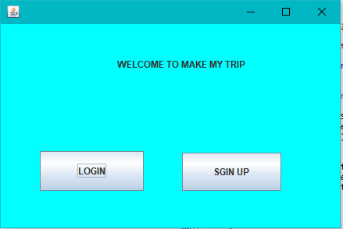

Frame 2:

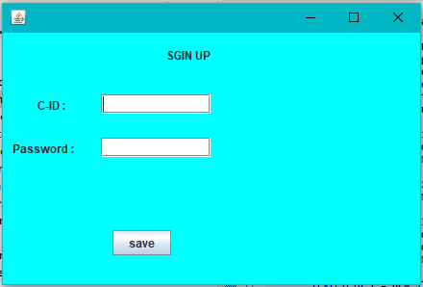

Frame 3:

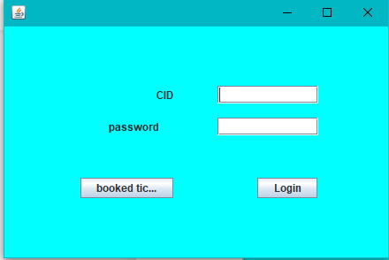

Frame 4:

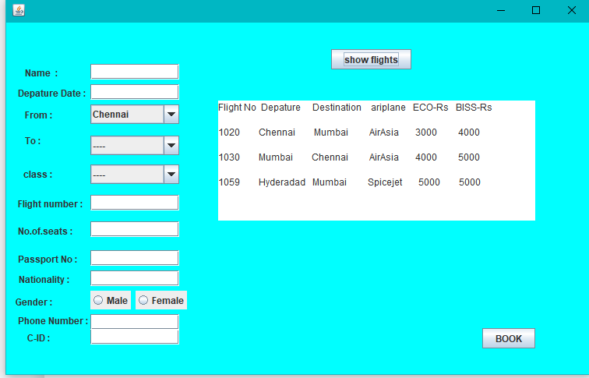

Frame 5:

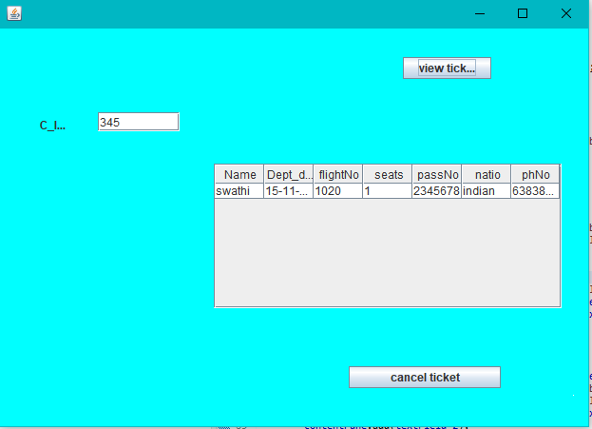

Frame 6:

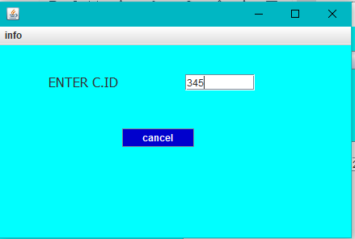

Result :